**Name : Khushi Nitinkumar Patel**

**PRN : 2020BTECS00037**

**EXPERIMENT NO 10**

**Title of experiment :** Largest and smallest number in an array of data.

**Equipment required :** GNU Simulator.

**Theory :**

**Algorithm for only smallest number.**

1.Load the address of the first element of the array in HL pair.  
2. Move the count to B - reg.  
3. Increment the pointer.  
4. Get the first data in A - reg.  
5. Decrement the count.  
6. Increment the pointer.  
7. Compare the content of memory addressed by HL pair with that of A - reg.  
8. If carry = 1, go to step 10 or if Carry = 0 go to step 9.  
9. Move the content of memory addressed by HL to A - reg.  
10. Decrement the count.  
11. Check for Zero of the count. If ZF = 0, go to step 6, or if ZF = 1 go to next step.  
12. Store the smallest data in memory.  
13. Terminate the program.

**Algorithm for only largest number.**

1.Load H-L pair with address of first operand’s memory location.

2.Move the first operand from memory to accumulator.

3.Increment H-L pair to point to next memory location.

4.Move the second operand from memory to register B.

5.Compare B with A.

If carry?

Yes🡪Move data from register B to accumulator.

No🡪Increment H-L pair.

6.Move the result from accumulator to memory.

**Program code :**

**;smallest of n numbers**

LXI H,1100

MOV C,M

INX H

DCR C

MOV A,M

loop: INX H

CMP M

JC skip

MOV A,M

skip: DCR C

JNZ loop

STA 1109

HLT

**;largest of n numbers**

LXI H,1100

MOV C,M

INX H

DCR C

MOV A,M

loop: INX H

CMP M

JNC skip

MOV A,M

skip: DCR C

JNZ loop

STA 1109

HLT

**Smallest of n numbers :**

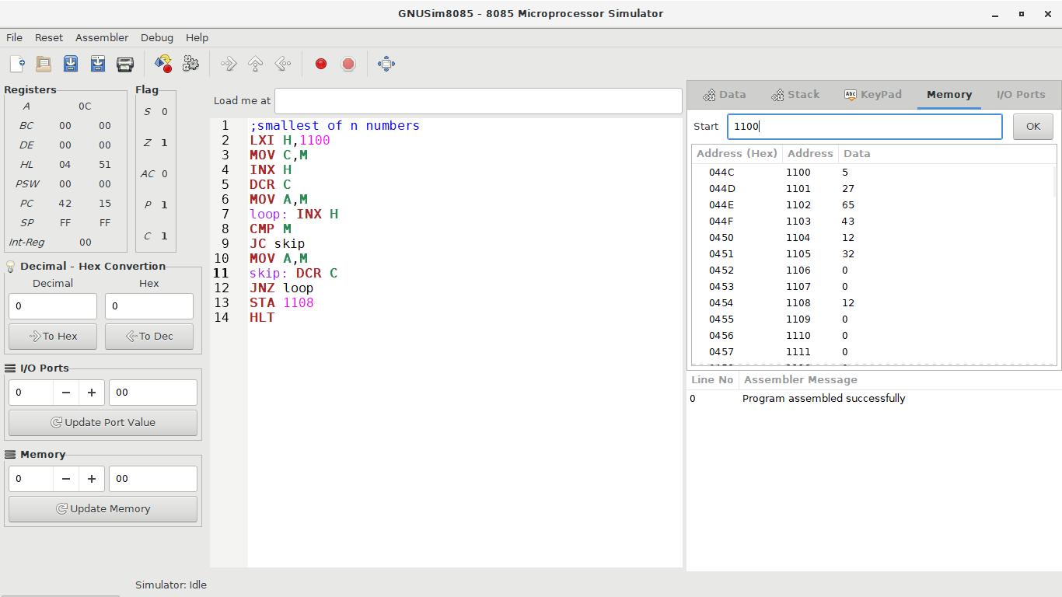

**Largest of n numbers :**

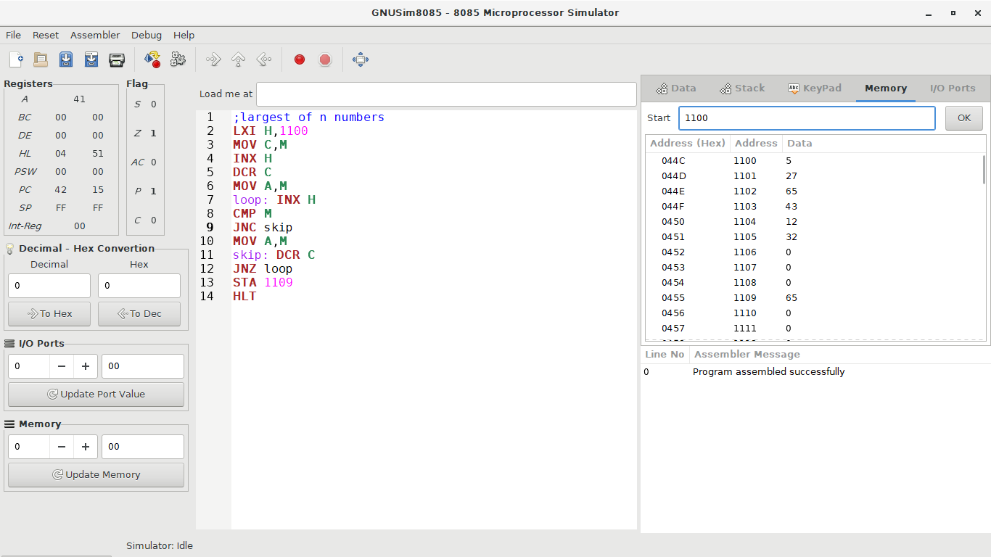

**Conclusion :** These are ways to design subtractor and comparator.